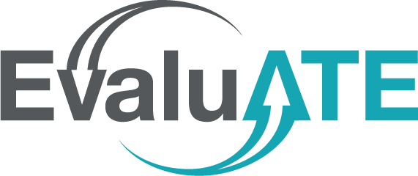  
An evaluation plan should include a clear description of what data will be collected, from what sources and how, by whom, and when, as well as how the data will be analyzed. Placing this information in a matrix helps ensure that there is a viable plan for collecting all the data necessary to answer each evaluation question and that all collected data will serve a specific, intended purpose. The table below may be copied into another document, such as a grant proposal, and edited/ expanded as needed. An example is provided on the next page.

**Data Collection Planning Matrix**

|  |  |  |  |  |  |
| --- | --- | --- | --- | --- | --- |
| **Evaluation Question:** | | | | | |
| **Indicator** | **Data Source and Methods** | **Responsible Party** | **Timing** | **Analysis Plan** | **Interpretation** |
|  |  |  |  |  |  |

If space is limited, such as in a National Science Foundation proposal, fewer columns may be used. It is most critical to include the evaluation questions, indicators, data sources and methods, and timing.

**DEFINITIONS**

**Evaluation Questions** are overarching questions about a project’s quality or impact. The number of evaluation questions depends on the scope and purpose of the evaluation; 3 to 7 questions is typical. Questions should address both project implementation and outcomes.

**Indicators** arespecific pieces of information about an aspect of a project—basically, what will be measured in order to answer the evaluation questions. It is useful to use multiple indicators to address an evaluation question, including qualitative and quantitative data.

**Data Sources** are the entities from which data will be collected. Typical data sources for ATE evaluations include project personnel, students, graduates, faculty, project partners, business and industry representatives, institutional records, website usage statistics, and teaching and learning artifacts.

**Data Collection Methods are** the means by which information will be gathered. Typical methods include surveys, focus groups, interviews, observations, and institutional database queries.

**Responsible Parties** are the individuals or organizations tasked with collecting the needed information. In many cases, data collection requires cooperation among multiple entities. For example, an external evaluator may be responsible for an administering a survey, but a member of the project staff may need to supply the contact information.

**Timing** identifies when and how frequently data will be collected (e.g., at events, quarterly, annually). It is important to identify approximately when data collection will take place to ensure the information will be obtained when needed for reporting purposes and decision making and that the data collection schedule is conducive to other things taking place in project’s context (e.g., other major data collection activities, semester schedules).

**Analysis Plan** how the quantitative and qualitative data will be summarized into meaningful, usable information.

**Interpretation** is how the analyzed data will be used to reach conclusions related to the evaluation questions.

**EXAMPLE**

|  |  |  |  |  |  |
| --- | --- | --- | --- | --- | --- |
| **Evaluation Question:** To what extent are students using education pathways established by the project? | | | | | |
| **Indicator** | **Data Source and Methods** | **Responsible Party** | **Timing** | **Analysis** | **Interpretation** |
| Number of high school students enrolled in the college’s wind energy technology courses | Institutional data | Project director obtains from institutional research office | End of each semester | Counts | Comparison with project target of 10 per semester |
| Percentage of dual-enrolled high school students who intend to pursue wind technology degrees or certificates | Survey of dual-enrolled students | External evaluator develops survey and conducts analyses; faculty administer survey | End of each semester | Descriptive statistics, disaggregated by demographic characteristics | Comparison with project target of 60% or more, , with one-third or more from underrepresented minority groups |
| Students’ perceptions of what affects their education or career interests | Focus group with | External evaluator | End of each spring semester | Inductive coding to determine factors that increase or suppress interest in wind technology | Identify which, if any, factors can be influenced by the program |
| Percentage of students who began has dual-enrolled who graduate with wind technology degrees or certificates | Institutional data | Project director obtains from institutional research office | End of each semester after first cohort is eligible to receive degree or certificate | Descriptive statistics, disaggregated by demographic characteristics | Comparison with project target of 40% or more, with one-third or more from underrepresented minority groups |



*This material is based upon work supported by the National Science Foundation under grant number 1600992. Any opinions, findings, and conclusions or recommendations expressed in this material are those of the author and do not necessarily reflect the views of NSF.*